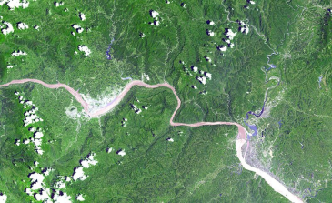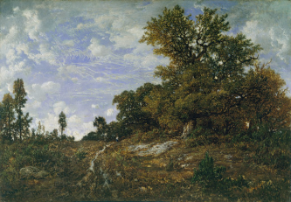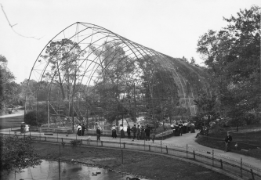

Center for History and Economics
with the support of the Harvard University Center for the Environment
October 31 2008
Prologue: The Environment and the United Nations
11.30am - 12.30pm
A Conversation with Gro Harlem Brundtland
(UN History Project, South Asia Initiative)
Introduction 2.00pm - 2.15pm
- Emma Rothschild
- David Blackbourn

Session One: Histories of Sustainability 2.15pm - 3.45pm
- Paul Warde (University of East Anglia)
The Invention of Sustainability
- Emma Rothschild (Harvard University)
Keeping (Environmental) Capital Intact

Session Two: The History of Environmental Policy 4.00pm - 5.30pm
- Alison Frank (Harvard University)
The Disappearance of an Oil Industry
- Sverker Sörlin (Royal Institute of Technology, Stockholm, Sweden)
The ecology of humanity: Exploring the roots of an idea
- Comments:
Anthony LaVopa (Modern Intellectual History, North Carolina State University)

Conclusions 5.30pm - 6.15pm
- David Blackbourn

